Paulson Renny

Reg No:2237016

2 MA Applied Economics

Date of Submission

29/03/20223



MA APPLIED ECONOMICS

DEPARTMENT OF ECONOMICS

CHRIST (DEEMED TO BE UNIVERSITY)

MARCH 2023

**SOLUTION:**

We have information regarding the date of the crime, city and type of the crime.

From Crime scene report table we get information regarding the murder that occurred.

Query:  
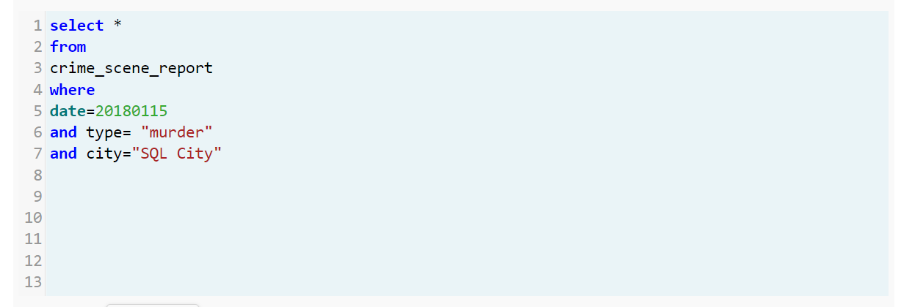

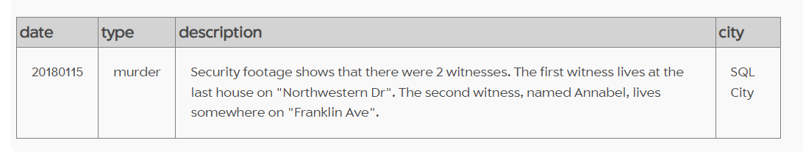

We know that there are two witnesses and the first witness lives at the last house on Northwestern Dr” and the second witness, named Annabel lives somewhere on Franklin Ave.

Query:

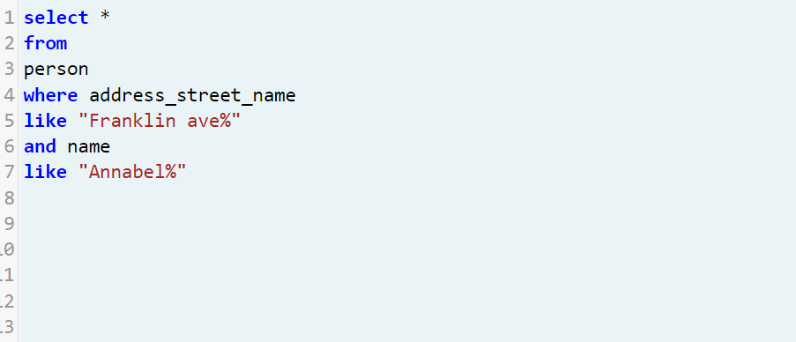

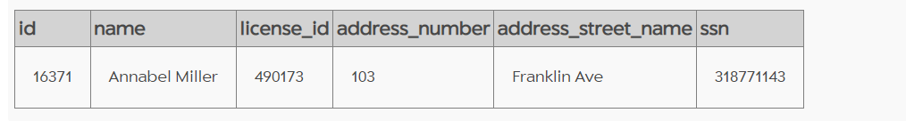

Query:

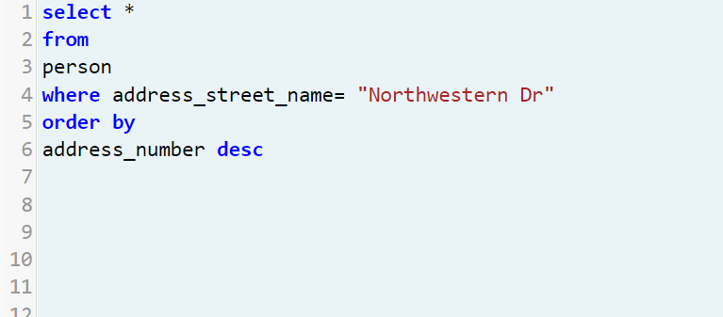

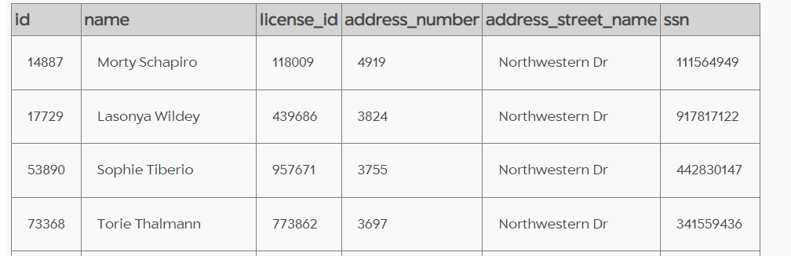

As the witness lives in the last house of Northwestern street we take the first row of the table, as the table is in descending order. Thus we find out about the two witnesses and they are Annabel Miller and Morty Schapiro.

Query:

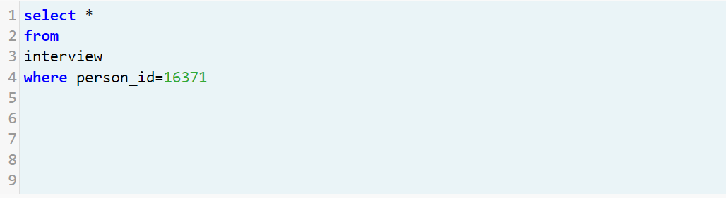

We obtain data from interview table and the interview of Annabel Miller is as follows:

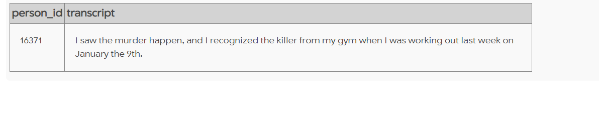

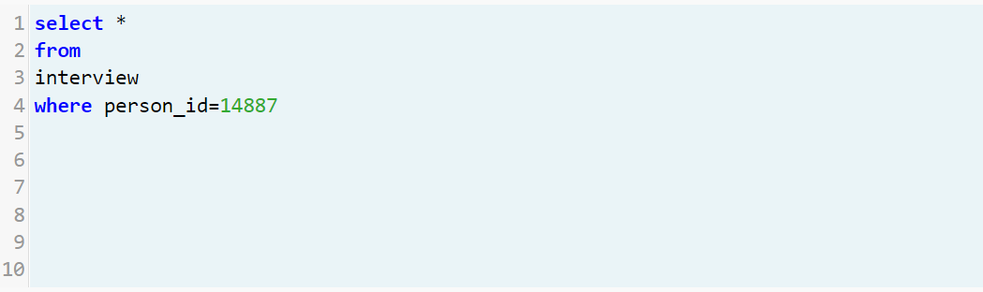

Interview of Morty Schapiro is as follows:

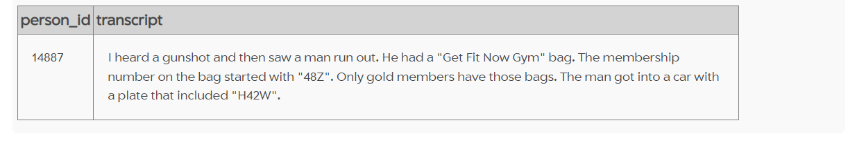

From the information obtained from the witnesses’ interviews, we can find out the murderer or suspects.

Query:

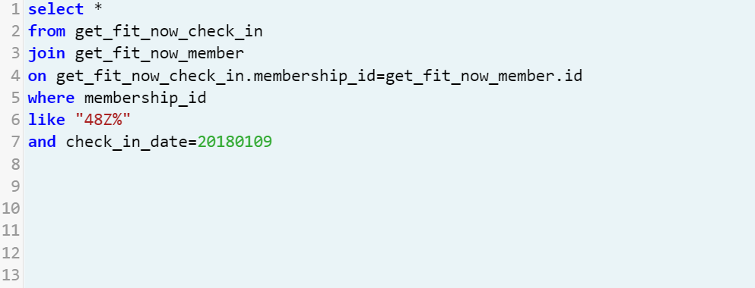

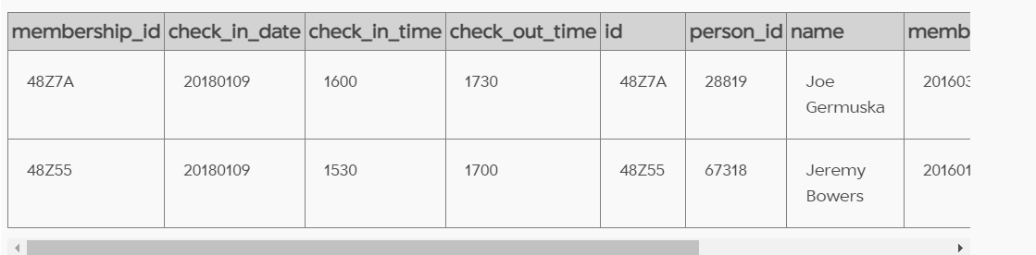

Query:

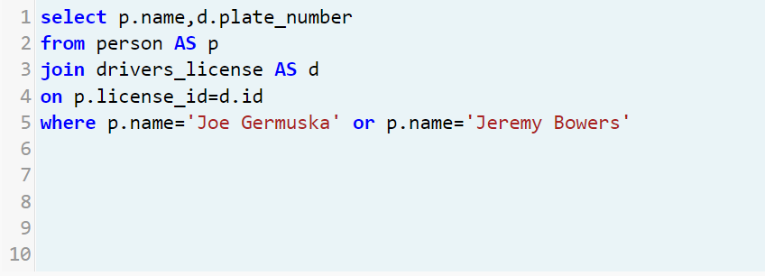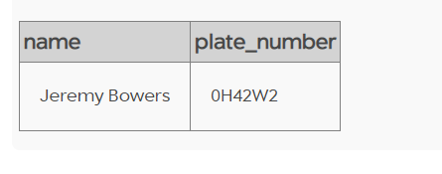

We get that the killer is Jeremy Bowers.

Query:

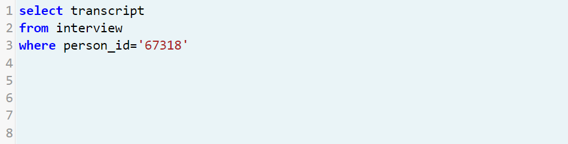

The interview of Jeremy is as follows:

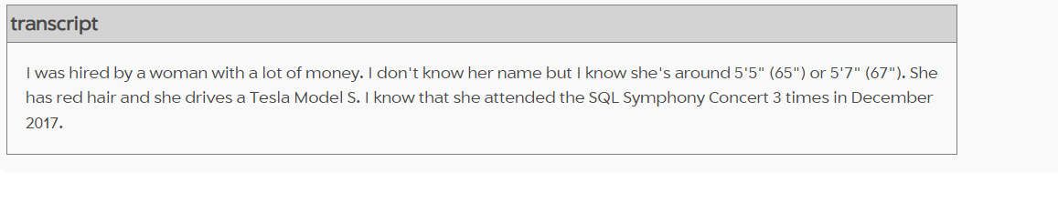

Query:

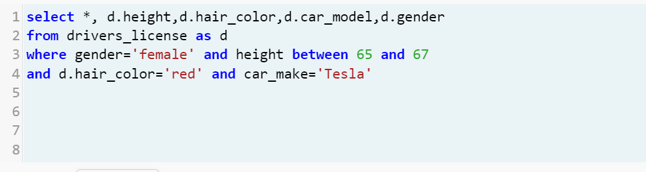

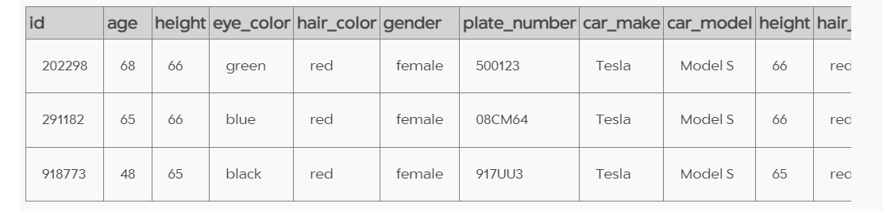

Query:

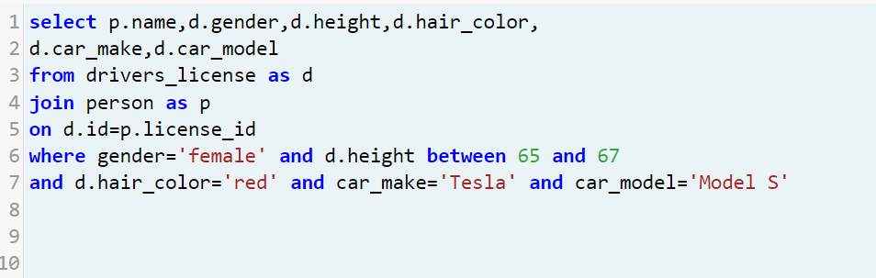

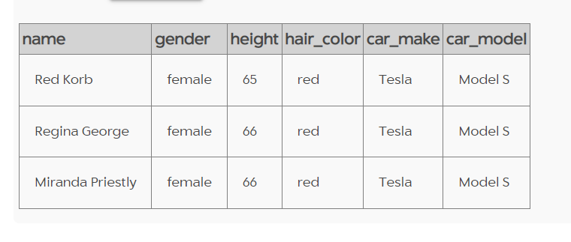

Query:

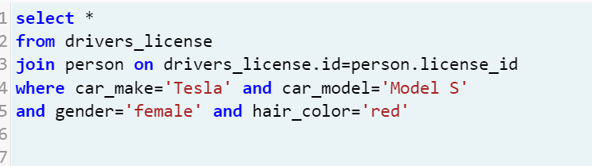

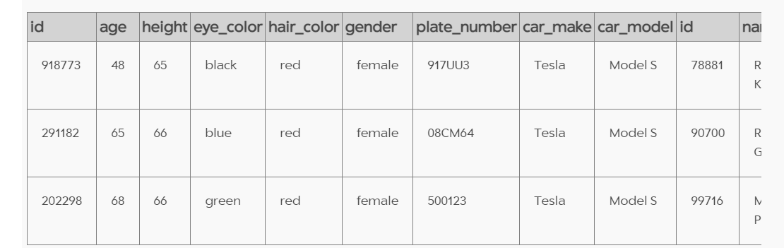

Query:

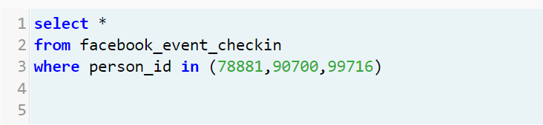

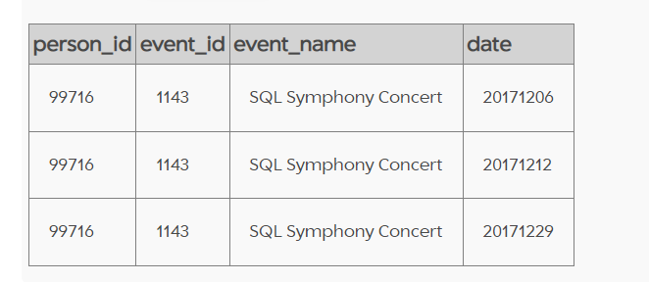

Query:

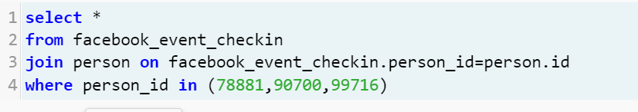

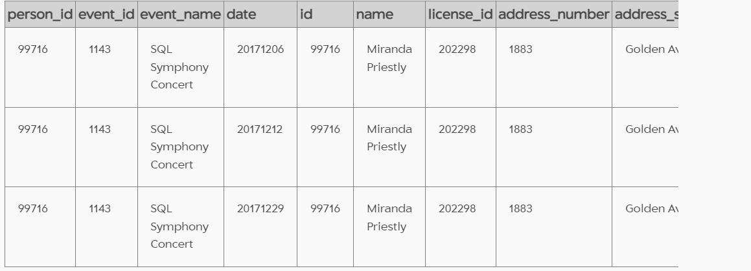

We can find out on basis of Jeremy’s interview, that Miranda Priestly was the woman who hired him to commit the crime and therefore Miranda Priestly is the mastermind of the crime.